BCSE-III Compiler Design Assignment-2
Regular Expression to Deterministic Finite Automaton Conversion
Name: Chirantan Nath
Roll: 101910501064 (Section A3)
Session: 2024-25.

Class Diagram:
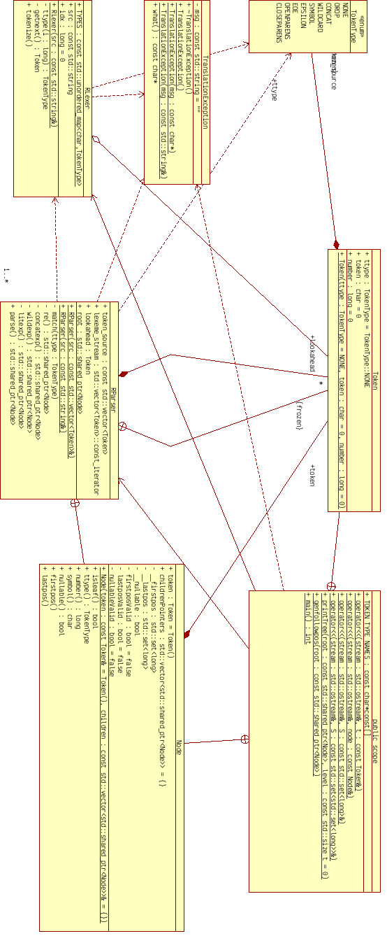

Sequence Diagram:
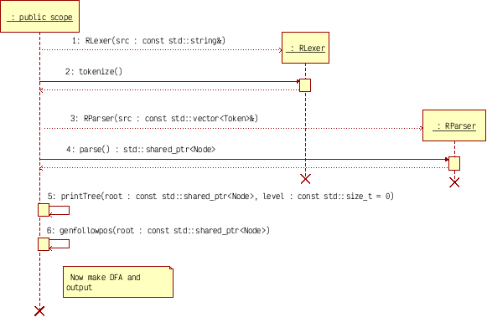

Code:
/*
Syntax rules for regex translation:
we have operators ()*.| and input symbols that are other than this; as well as
an EOE identifier (which counts as a symbol). SYMBOLS consists of any other
letters that are not part of the specification we are listing as well as the
special symbol ? which stands for epsilon/empty string FOR THE RE and not for
us. . is implicit sometimes and has a higher precedence than |
* has a higher precedence than .
all operators are left-associative

Start with the lowest precedence; i.e. an re or nothing
re ::= re|concatexp OR concatexp
We don't need epsilon specification above because we will always have an EOE
symbol. concatexp ::= concatexpwildexp OR concatexp.wildexp OR wildexp wildexp
::= litexp* OR litexp litexp ::= SYMBOL OR ? OR (re)

Therefore, tokens are SYMBOLs, operators *.| (. being possibly implicit) and
parentheses ().
*/

#include <cassert>
#include <exception>
#include <iostream>
#include <map>
#include <memory>
#include <set>
#include <sstream>
#include <stack>
#include <string>
#include <unordered_map>
#include <utility>
#include <vector>
using namespace std;

enum TokenType {
NONE,
OROP,
CONCAT,
WILDCARD,
SYMBOL,
EPSILON,
EOE,
OPENPARENS,
CLOSEPARENS
};
static const char *const TOKEN_TYPE_NAMES[] = {
"none", "|", ".", "*", "symb", "epsilon", "eoe", "(", ")"};

class TranslationException : public virtual exception {
const string msg;

public:
virtual ~TranslationException() = default;
TranslationException() = default;
TranslationException(const char *msg) : msg(msg) {}
TranslationException(const string &msg) : msg(msg) {}
const char *what() const noexcept override { return msg.c_str(); }
};

struct Token {
TokenType ttype;
char token;
long number;

Token(TokenType ttype = NONE, char token = 0, long number = 0)
: ttype(ttype), token(token), number(number) {}
};
inline ostream &operator<<(ostream &stream, const Token &t) {
stream << '[' << TOKEN_TYPE_NAMES[t.ttype] << ' ';
if (t.token)
stream << t.token;
else
stream << "null";
stream << ' ';
if (t.number)
stream << t.number;
else
stream << "null";
stream << ']';
return stream;
}

struct RLexer {
static const unordered_map<char, TokenType> TYPES;

const string src;
long idx;

RLexer(const string &src) : src(src), idx(0) {}

private:
TokenType ttype(long i) const {
if (i >= src.length())
return EOE;
auto itr = TYPES.find(src[i]);
return itr == TYPES.end() ? SYMBOL : itr->second;
}

Token getnext() const {
Token token;
token.ttype = ttype(idx);
if (EOE != token.ttype)
token.token = src[idx];
return token;
}

public:
vector<Token> tokenize() {
vector<Token> tokens;
long parencount = 0;
Token current;
idx = 0;
TokenType &ttype = current.ttype;

while (true) {
current = getnext();
tokens.push_back(current);

if (EOE == current.ttype)
break;
idx++;

switch (current.ttype) {
case OPENPARENS:
parencount++;
break;
case CLOSEPARENS:
parencount--;
break;
default:
break;
}

if (ttype == SYMBOL || ttype == EPSILON || ttype == WILDCARD ||
ttype == CLOSEPARENS) {
const auto newttype = this->ttype(idx);
if (newttype == SYMBOL || newttype == EPSILON || newttype == OPENPARENS)
tokens.emplace_back(TokenType::CONCAT, '.');
}
}

if (parencount != 0)
throw TranslationException(to_string(parencount) +
" unbalanced parentheses");

long numberGen = 1;
for (size_t i = 0; i < tokens.size(); i++) {
if (tokens[i].ttype == SYMBOL || tokens[i].ttype == EOE) {
tokens[i].number = numberGen;
numberGen++;
}
}

tokens.shrink_to_fit();
return tokens;
}
};
const decltype(RLexer::TYPES) RLexer::TYPES = {
{'|', OROP}, {'.', CONCAT}, {'*', WILDCARD},
{'?', EPSILON}, {'(', OPENPARENS}, {')', CLOSEPARENS}};

struct Node {
using Nodeptr = shared_ptr<Node>;

Token token;
vector<Nodeptr> childrenPointers;

private:
set<long> __firstpos, __lastpos;
bool __nullable, firstposValid, lastposValid, nullableValid;

public:
Node(const Token &token = Token(),
const vector<Nodeptr> &children = vector<Nodeptr>())
: token(token), childrenPointers(children), firstposValid(false),
lastposValid(false), nullableValid(false) {
childrenPointers.reserve(3);
}

bool isleaf() const noexcept { return childrenPointers.empty(); }
TokenType ttype() const noexcept { return token.ttype; }
long number() const noexcept { return token.number; }
char symbol() const noexcept { return token.token; }

// Compute nullable attribute
bool nullable() {
if (nullableValid)
return __nullable;

const TokenType ttype = this->ttype();
if (ttype == OROP) {
// If any child is nullable irrespective of order, we are nullable
__nullable = false;
for (auto child : childrenPointers)
if (child->nullable()) {
__nullable = true;
break;
}
} else if (ttype == CONCAT) {
// Here all of it must be nullable in order to be nullable
__nullable = true;
for (auto child : childrenPointers)
if (!child->nullable()) {
__nullable = false;
break;
}
} else
__nullable = ttype == EPSILON || ttype == WILDCARD;

nullableValid = true;
return __nullable;
}

// Compute firstpos
const set<long> &firstpos() {
if (firstposValid)
return __firstpos;
const TokenType ttype = this->ttype();

if (isleaf()) {
if (number())
__firstpos = set<long>({number()});
else
__firstpos.clear();
} else if (ttype == OROP) {
// firstpos is union of firstpos of all children
for (auto child : childrenPointers) {
const auto &childFirstpos = child->firstpos();
__firstpos.insert(childFirstpos.begin(), childFirstpos.end());
}
} else if (ttype == WILDCARD) {
__firstpos = childrenPointers.front()->firstpos();
} else {
assert(ttype == CONCAT);
__firstpos.clear();
for (auto child : childrenPointers) {
const auto &childFirstpos = child->firstpos();
__firstpos.insert(childFirstpos.begin(), childFirstpos.end());
if (!child->nullable())
break;
}
}

firstposValid = true;
return __firstpos;
}

// Compute lastpos
const set<long> &lastpos() {
if (lastposValid)
return __lastpos;
const TokenType ttype = this->ttype();

if (isleaf()) {
if (number())
__lastpos = set<long>({number()});
else
__lastpos.clear();
} else if (ttype == OROP) {
// lastpos is union of lastpos of all children
for (auto child : childrenPointers) {
const auto &childLastpos = child->lastpos();
__lastpos.insert(childLastpos.begin(), childLastpos.end());
}
} else if (ttype == WILDCARD) {
__lastpos = childrenPointers.back()->lastpos();
} else {
assert(ttype == CONCAT);
__lastpos.clear();
// Needs to be done sequentially but in REVERSE
for (auto itr = childrenPointers.rbegin(); itr != childrenPointers.rend();
itr++) {
auto child = *itr;
const auto &childLastpos = child->lastpos();
__lastpos.insert(childLastpos.begin(), childLastpos.end());
if (!child->nullable())
break;
}
}

lastposValid = true;
return __lastpos;
}

// Followpos not computed here.
};
inline ostream &operator<<(ostream &stream, const Node &node) {
stream << node.token;
return stream;
}

struct RParser {
using Nodeptr = Node::Nodeptr;

const vector<Token> token_source;
decltype(token_source)::const_iterator lexeme_stream;
Token lookahead;
Nodeptr root;

RParser(const vector<Token> &src) : token_source(src) {}
RParser(const string &src) : RParser(RLexer(src).tokenize()) {}

private:
void match(TokenType ttype) {
if (lookahead.ttype == ttype) {
lexeme_stream++;
if (lexeme_stream == token_source.cend()) {
if (ttype != EOE)
throw TranslationException(
"expected " + string(TOKEN_TYPE_NAMES[ttype]) + ", found eoe");
else
return;
} else
lookahead = *lexeme_stream;
} else
throw TranslationException("expected " + string(TOKEN_TYPE_NAMES[ttype]) +
", found " +
string(TOKEN_TYPE_NAMES[lookahead.ttype]));
}

// Stage 1: handle |
Nodeptr re() {
Nodeptr root = concatexp();
while (lookahead.ttype == OROP) {
Nodeptr leftchild = root;
root = Nodeptr(new Node(lookahead, {leftchild}));
match(OROP);
Nodeptr rightchild = concatexp();
root->childrenPointers.push_back(rightchild);
}
return root;
}

// Stage 2: handle .
// Cannot handle implicit concatenation
Nodeptr concatexp() {
Nodeptr root = wildexp();
while (lookahead.ttype == CONCAT) {
Nodeptr leftchild = root;
root = Nodeptr(new Node(lookahead, {leftchild}));
match(CONCAT);
Nodeptr rightchild = wildexp();
root->childrenPointers.push_back(rightchild);
}
return root;
}

// Stage 3: handle *
Nodeptr wildexp() {
Nodeptr root = litexp();
if (lookahead.ttype != WILDCARD)
return root;
Nodeptr child = root;
root = Nodeptr(new Node(lookahead, {child}));
match(WILDCARD);
return root;
}

// Stage 4: handle literals EXCEPT end-of-expression
Nodeptr litexp() {
Nodeptr root;
switch (lookahead.ttype) {
case SYMBOL:
case EPSILON:
root = Nodeptr(new Node(lookahead));
match(lookahead.ttype);
return root;
case OPENPARENS:
match(OPENPARENS);
root = re();
match(CLOSEPARENS);
return root;
default:
ostringstream tokenDesc;
tokenDesc << lookahead;
throw TranslationException("Unexpected " + tokenDesc.str());
}
}

public:
Nodeptr parse() {
lexeme_stream = token_source.cbegin();
if (lexeme_stream == token_source.cend())
throw TranslationException("No expression present!");
lookahead = *lexeme_stream;
Nodeptr leftchild = re(); // Need to concatenate eoe here with re.
match(EOE); // This should NOT modify lookahead
Nodeptr rightchild = Nodeptr(new Node(lookahead));
root = Nodeptr(new Node(Token(CONCAT, '.'), {leftchild, rightchild}));
return root;
}
};

inline ostream &operator<<(ostream &stream, const set<long> &S) {
size_t i = 0;
stream << '{';
for (auto itr = S.begin(); itr != S.end(); i++, itr++) {
stream << *itr;
if (i < (S.size() - 1))
stream << ", ";
}
stream << '}';
return stream;
}

inline ostream &operator<<(ostream &stream, const set<set<long>> &S) {
size_t i = 0;
stream << '{';
for (auto itr = S.begin(); itr != S.end(); i++, itr++) {
stream << *itr;
if (i < (S.size() - 1))
stream << ", ";
}
stream << '}';
return stream;
}

void printTree(const Node::Nodeptr root, const size_t level = 0) {
for (size_t i = 0; i < level; i++)
cout << "->\t";
cout << root->firstpos();
cout << *root;
cout << (root->nullable() ? "?" : "");
cout << root->lastpos();
cout << endl;
// The reason we traverse in reversed order is because the tree grows down
// to the left.
for (auto itr = root->childrenPointers.crbegin();
itr != root->childrenPointers.crend(); itr++) {
const Node::Nodeptr child = *itr;
printTree(child, level + 1);
}
}

inline map<long, set<long>> genfollowpos(const Node::Nodeptr root) {
map<long, set<long>> followpos;
stack<Node::Nodeptr> stck;
stck.push(root);

while (!stck.empty()) {
Node::Nodeptr node = stck.top();
stck.pop();
Node::Nodeptr leftchild, rightchild;
switch (node->ttype()) {
case CONCAT:
leftchild = node->childrenPointers[0];
rightchild = node->childrenPointers[1];
for (long i : leftchild->lastpos()) {
set<long> iset;
auto found = followpos.find(i);
if (found != followpos.end())
iset = std::move(found->second);
const auto &insertion = rightchild->firstpos();
iset.insert(insertion.begin(), insertion.end());
followpos[i] = std::move(iset);
}
break;
case WILDCARD:
for (long i : node->lastpos()) {
set<long> iset;
auto found = followpos.find(i);
if (found != followpos.end())
iset = std::move(found->second);
const auto &insertion = node->firstpos();
iset.insert(insertion.begin(), insertion.end());
followpos[i] = std::move(iset);
}
break;
default:
break;
}
for (Node::Nodeptr child : node->childrenPointers)
stck.push(child);
}

return followpos;
}

int main() {
string expr;
cout << "Enter your expression.\n";
getline(cin, expr);

Node::Nodeptr root;

try {
const auto tokens = RLexer(expr).tokenize();
// cout << "Tokens:\n";
// for (const Token &token : tokens)
// cout << token << endl;

cout << "\nTrying to generate tree...\n";
root = RParser(tokens).parse();
} catch (const exception &ex) {
cerr << "Error: " << ex.what() << endl;
return 1;
}

cout << "Read the following tree FROM BOTTOM TO TOP.\n";
printTree(root);
cout << "End of tree.\n\n";

const auto followpos = genfollowpos(root);
cout << "Followpos sets:\n";
for (const auto &entry : followpos)
cout << entry.first << ": " << entry.second << endl;
cout << endl;

// Input symbol set of the final DFA.
set<char> inputSymbols;
// Maps positions to symbols. This is internal, hence can be a hash table.
unordered_map<long, char> symbolCorresp;

// Generate input symbols and correspondence map.
{
stack<Node::Nodeptr> stck;
stck.push(root);
while (!stck.empty()) {
Node::Nodeptr node = stck.top();
stck.pop();
if (node->ttype() == SYMBOL) {
inputSymbols.insert(node->symbol());
symbolCorresp[node->number()] = node->symbol();
}
for (Node::Nodeptr child : node->childrenPointers)
stck.push(child);
}
}

set<set<long>> dStates, markedStates;
dStates.insert(root->firstpos());

// Transitions map
map<set<long>, map<char, set<long>>> transitions;

while (true) {
// Find a states in dStates that is NOT in marked
auto Sitr = dStates.cbegin();
for (; Sitr != dStates.cend(); Sitr++)
if (markedStates.find(*Sitr) == markedStates.end())
goto stateFound;
assert(Sitr == dStates.cend());
break; // No unmarked found

stateFound:
const set<long> &S = *Sitr;
markedStates.insert(S);

for (char a : inputSymbols) {
set<long> U;
for (const auto &fe : followpos) {
const long p = fe.first;
if (S.find(p) == S.end())
continue; // Skip if followpos key is not in S

if (symbolCorresp[p] == a)
U.insert(fe.second.cbegin(), fe.second.cend());
}
dStates.insert(U);

map<char, set<long>> transition;
auto Titr = transitions.find(S);
if (Titr != transitions.end())
transition = std::move(Titr->second);
transition[a] = U;
transitions[S] = std::move(transition);
}
}

cout << "All DFA states: " << dStates << "\n\n";

cout << "DFA transitions are:\n";
for (const auto &S : dStates) {
cout << "For state " << S << endl;
for (char a : inputSymbols)
cout << "On input symbol " << a << " we go to " << transitions[S][a]
<< endl;
cout << endl;
}

set<set<long>> acceptStates;
for (const auto &S : dStates) {
// S is an accept state if it contains any common element with
// root->lastpos()
for (long p : root->lastpos())
if (S.find(p) != S.end()) {
acceptStates.insert(S);
goto nextAcceptState;
}
nextAcceptState:;
}

cout << "Start state: " << root->firstpos() << endl;
cout << "Accept states: " << acceptStates << endl;
}

Output:
